Steps To Move Element in PRODUCTION

Step 1> Make the element available in your Test PDS.

Step 2> Go to endeavor TEST environment. Option: 1

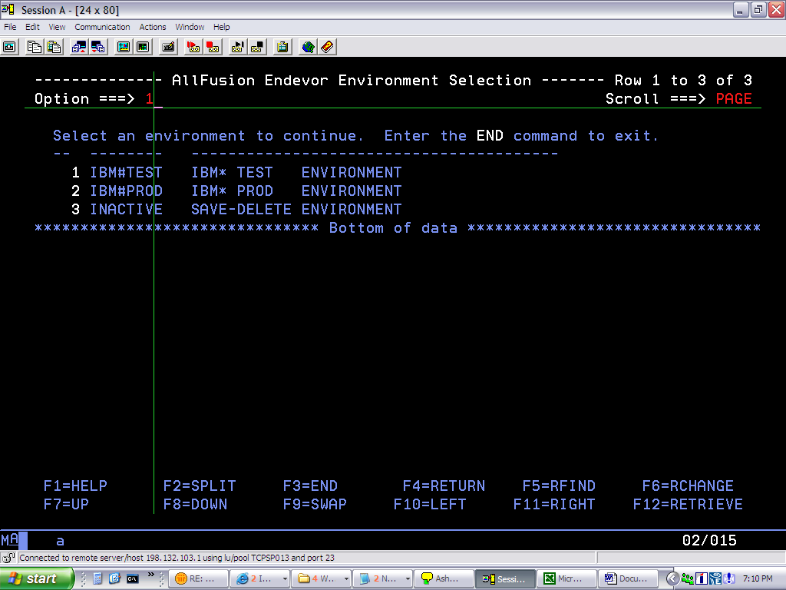

Go To Option: 2 (foreground)

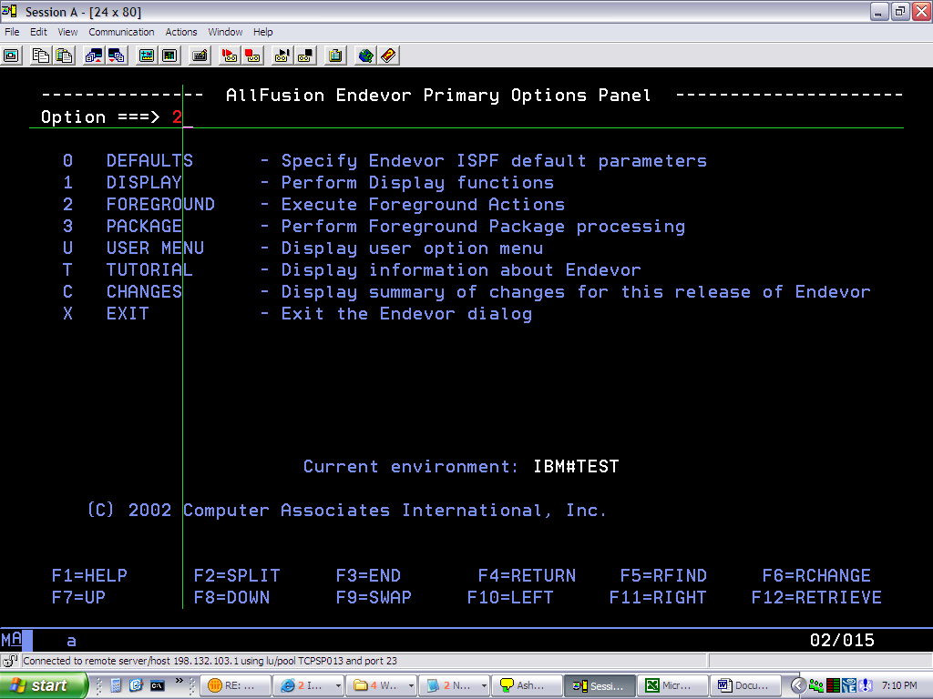

Then ADD the element to Test.

Option:2

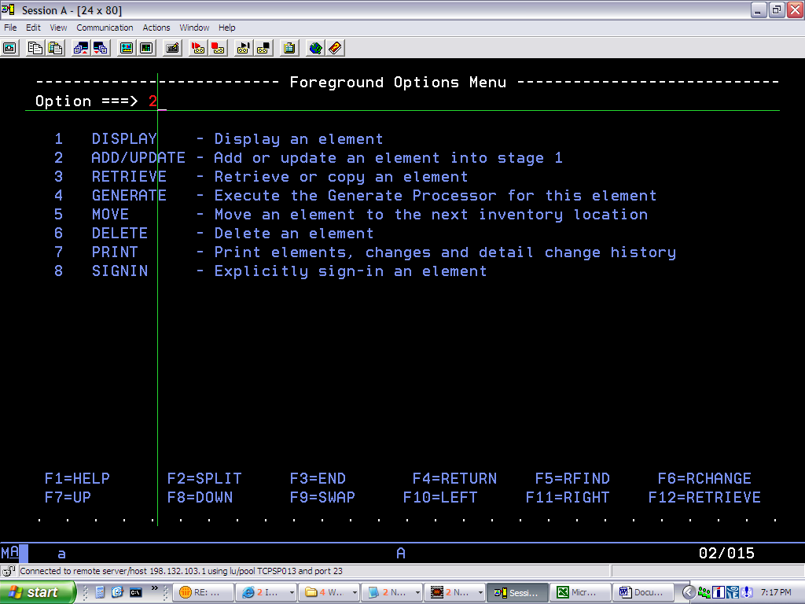

Give the ISPF Lib name where the element is present
Give any CCID Name
Then type A (add) on command line.
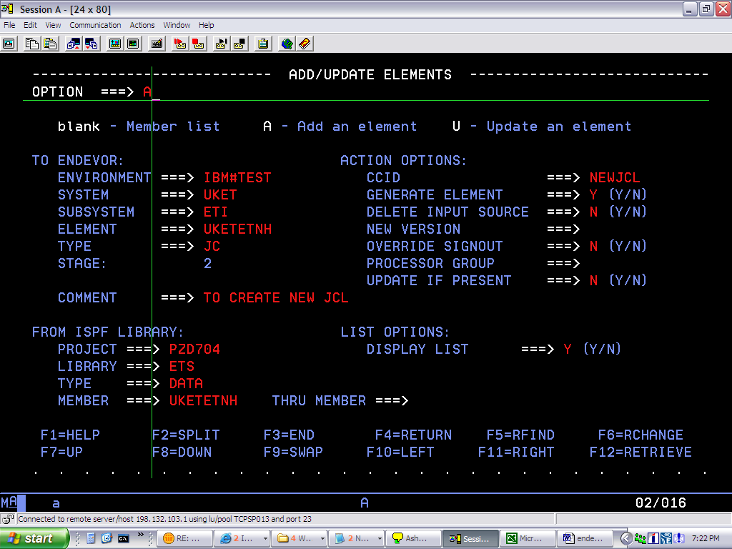

Once Add you will get the below message.

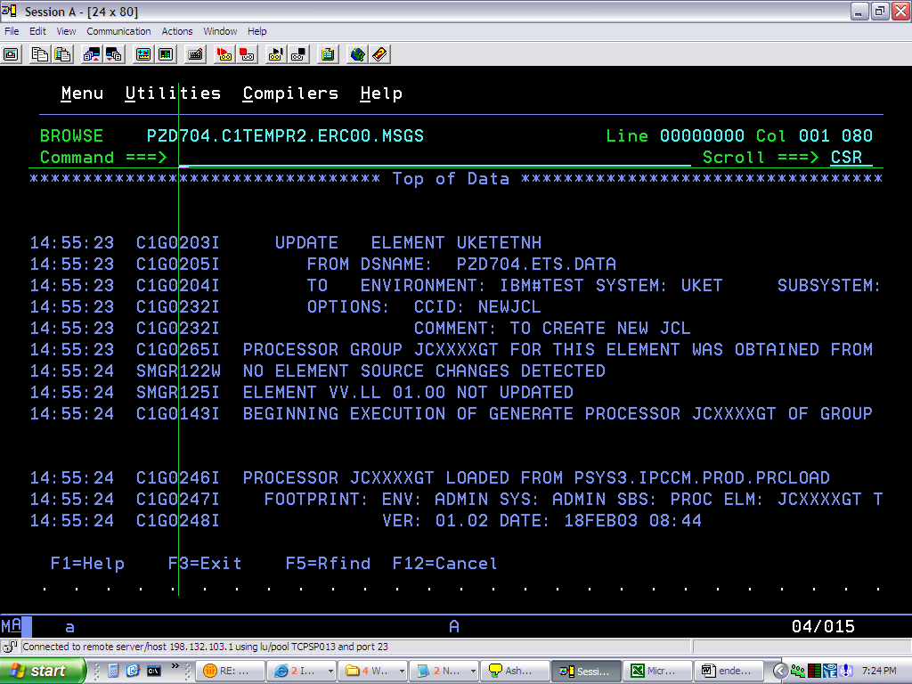

Step 3>
Then press F3
Go to option 5 ie MOVE
This will move the element from stage 2 to 3
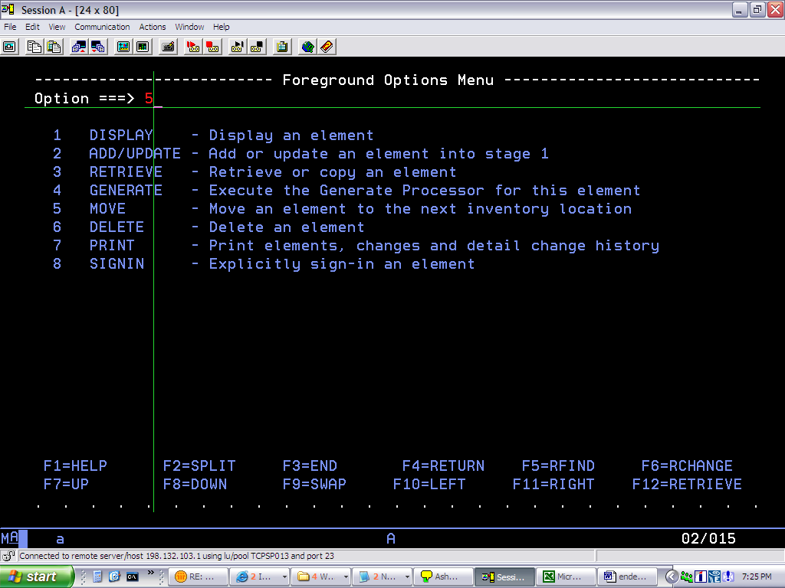

Type “O” on command Line then press ENTER
You will get the Message on Top-Right Corner
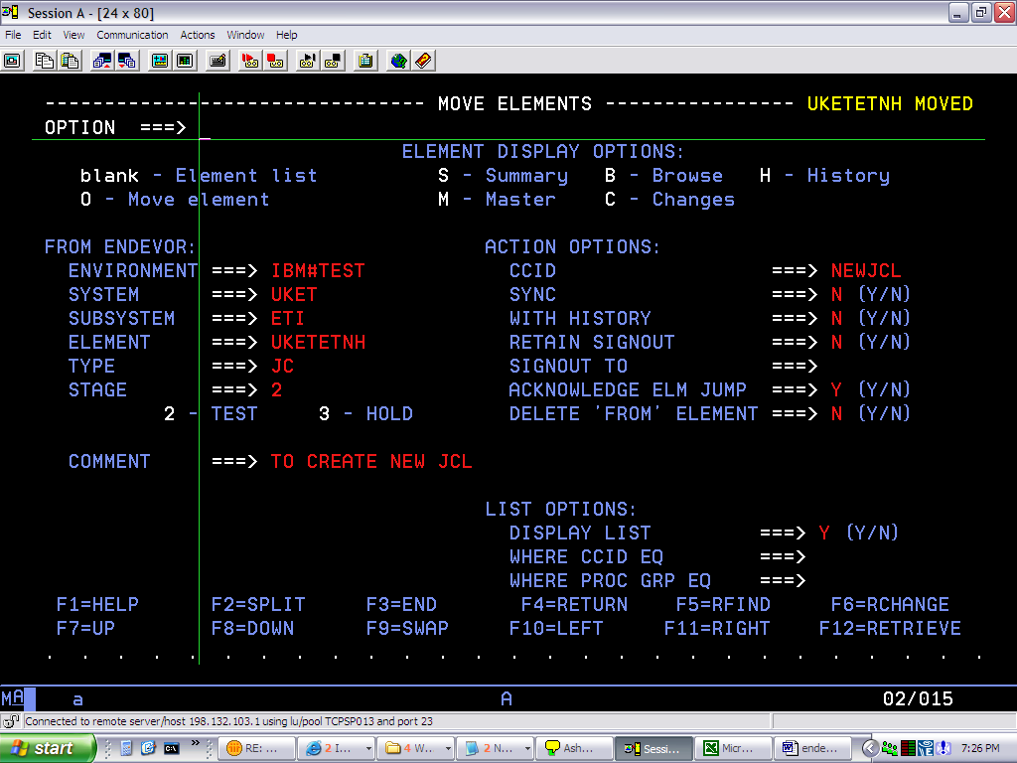

Step 4>
Then Create PACKAGE.

Go to Option: 3
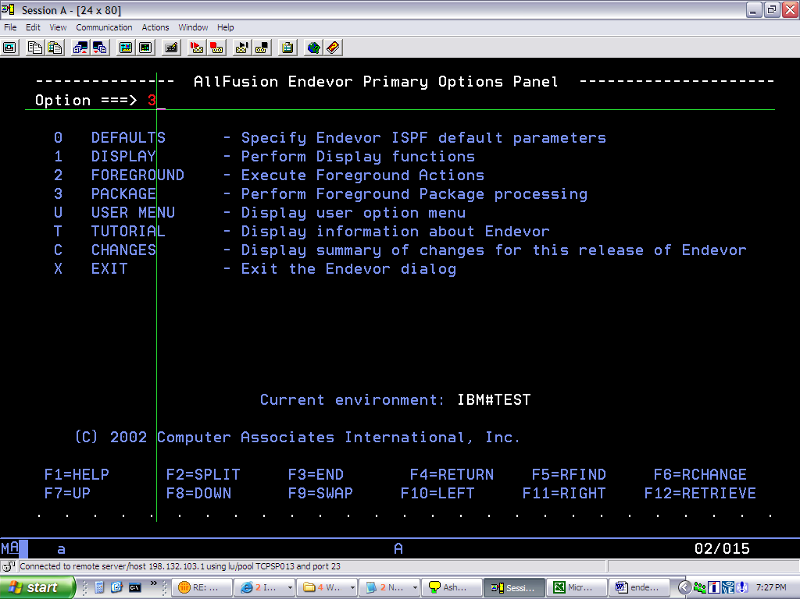

Then GO TO
Option: 2 (create/modify Package) screen shot not available
Give Package Name.

Then type Option: B (Build Package)

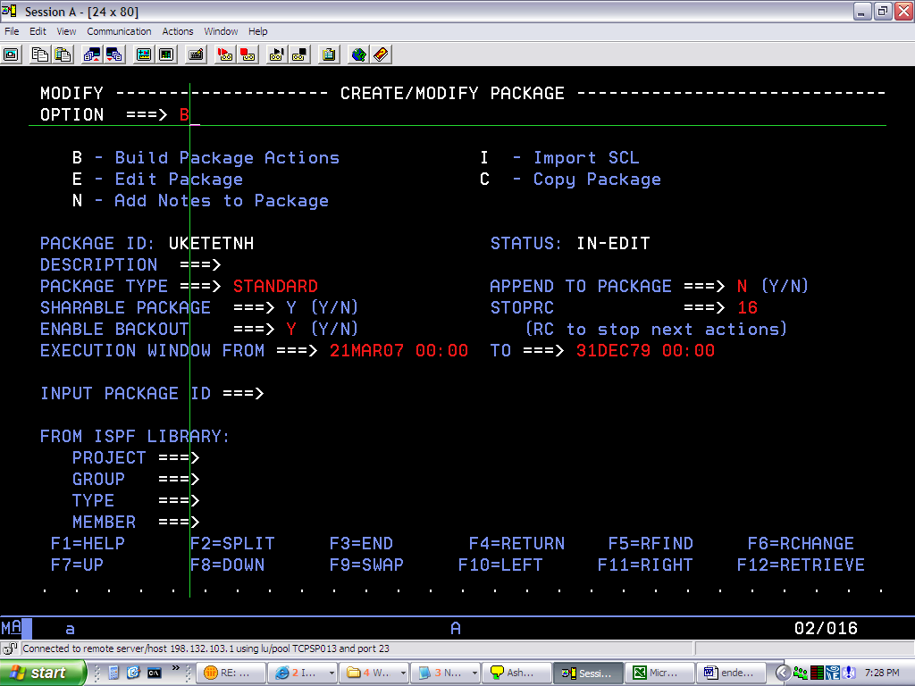

Step 5>
Then again MOVE the element to Package

Type “O” on command line, Press enter

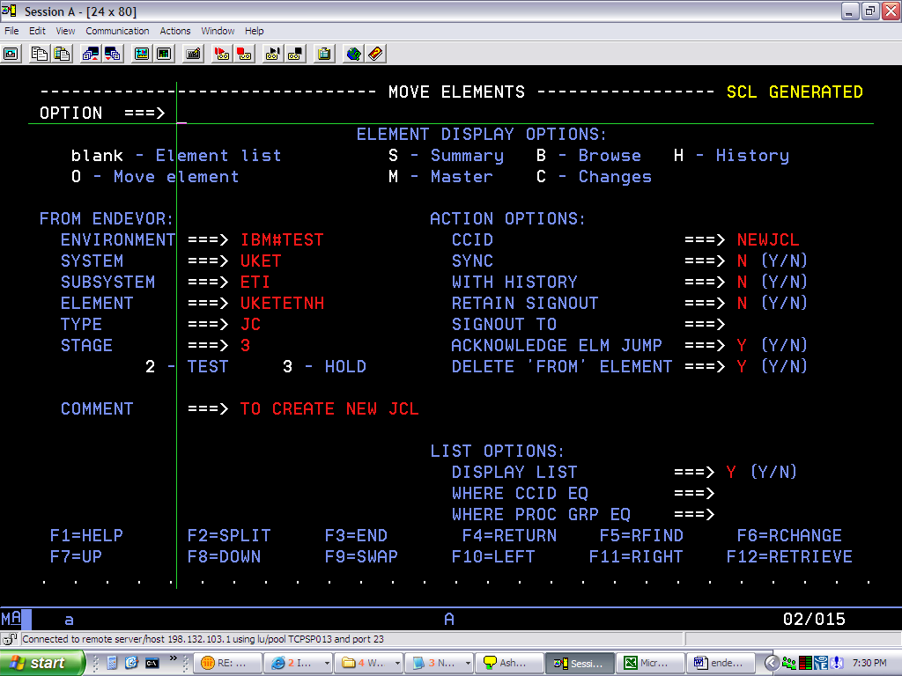

Step 6>
Then press F3
Go to CAST Package. Option :3

Type “C” on command line. Press enter
You will get Message On Top-Right “ Cast successful”
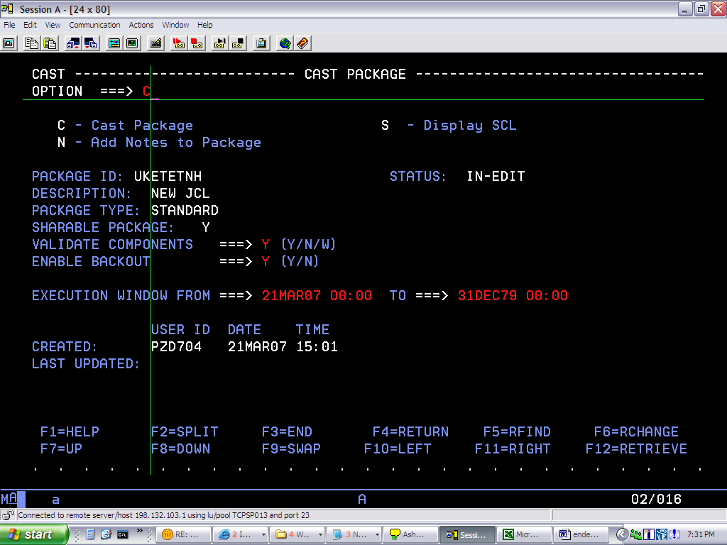

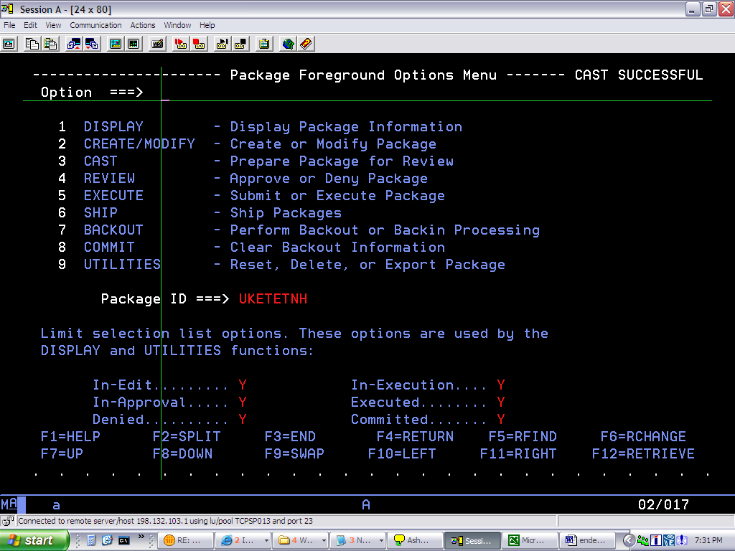

Step 7> APPROVE PACKAGE
Then login to any others ID for APPROVAL
Type S on command line for corresponding package

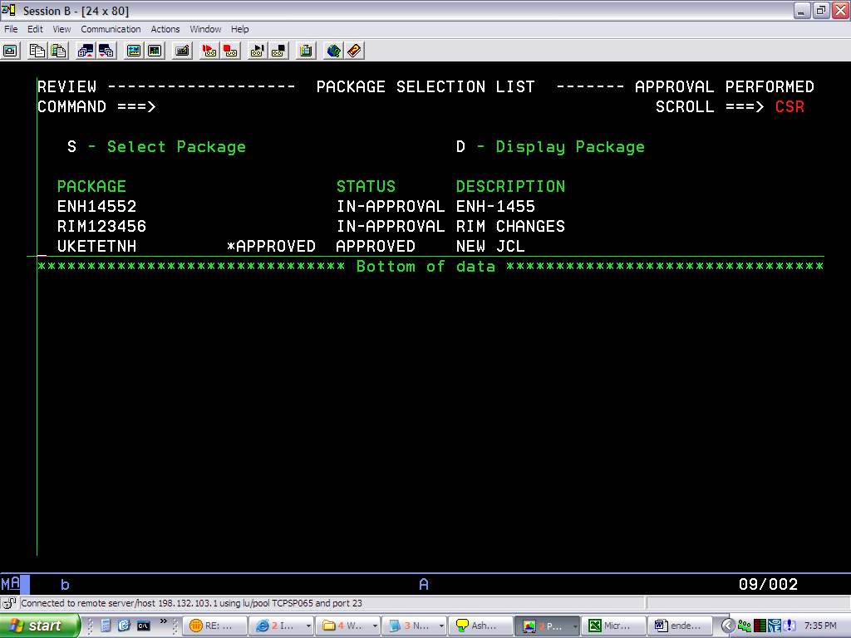

Step 8> EXECUTE PACKAGE

Then finally Execute the package
Go to Option: 5 (EXECUTE)
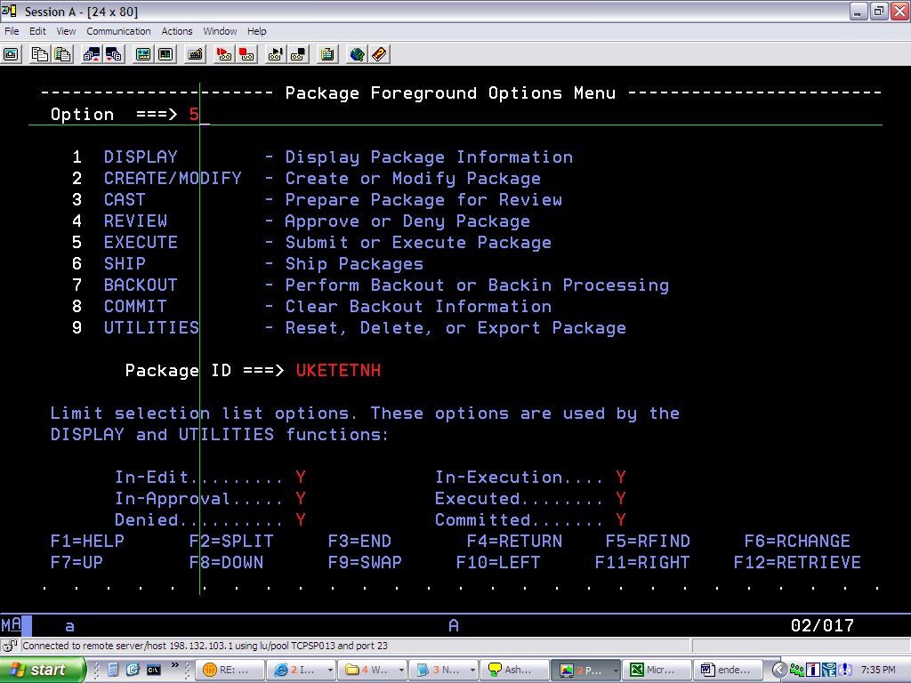

Step 9> SUBMIT PACKAGE
Then type S on command line, Submit package
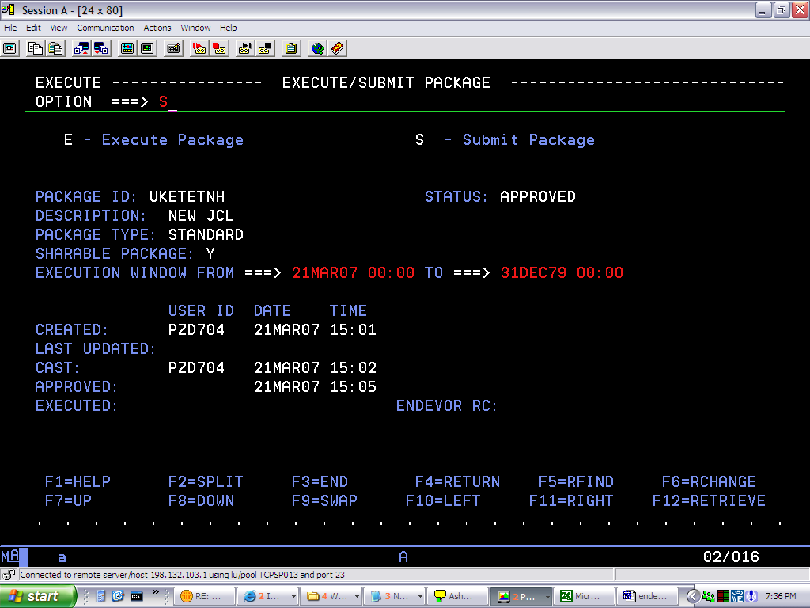

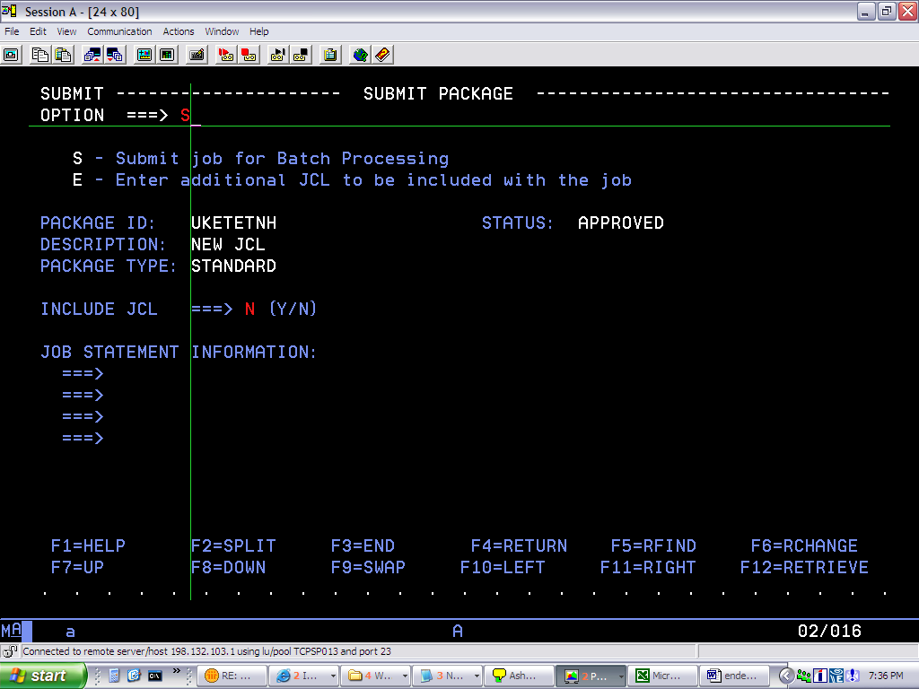

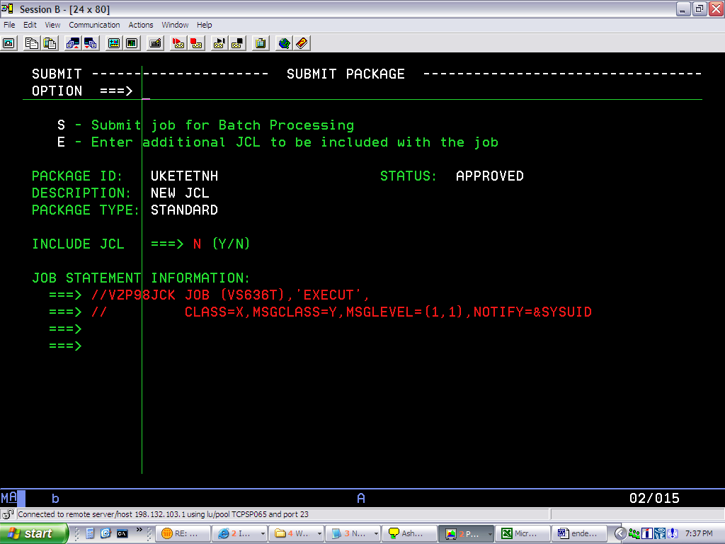

Step 10> COMMIT PACKAGE
Then At last GO TO option 8 (Commit)
To commit the package

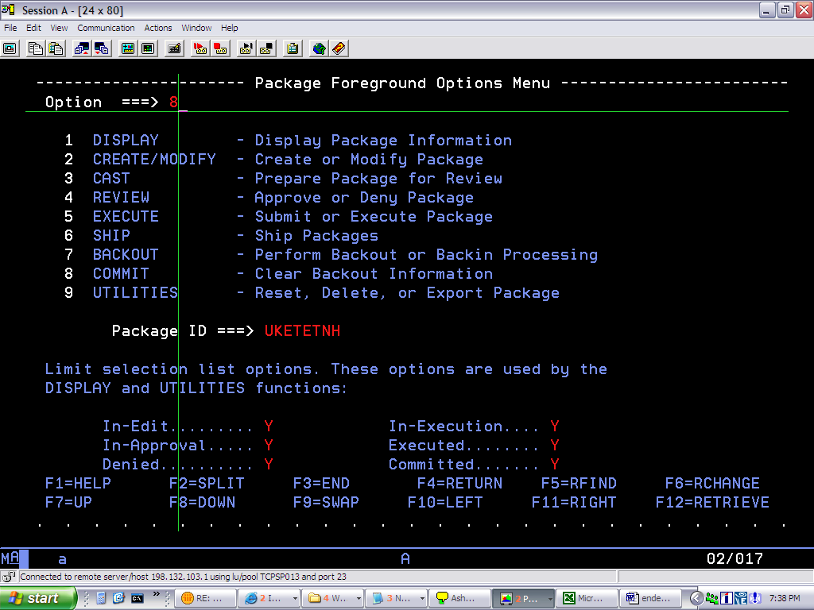

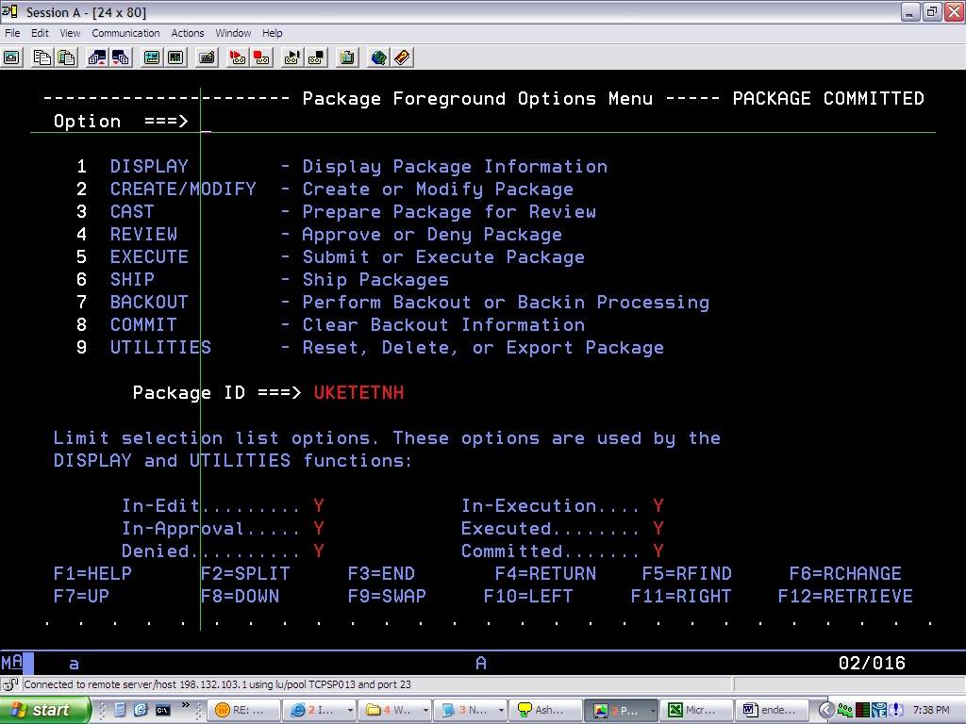

ELEMENT MOVE TO THE PROCUTION

END…..

